Princess Sumaya University for Technology

King Abdullah II Faculty of Engineering



**Microprocessors & Embedded Systems 22442– Fall 2022**

**Project: Vending machine**

|  |  |  |
| --- | --- | --- |
| **Student name** | **Student ID** | **major** |
| **Tarek Salameh** | **20190217** | **Computer engineering** |
| **Lina Abu-Ghosh** | **20190876** | **NIS engineering** |
| **Dima Hussein** | **20190581** | **Computer engineering** |

**Instructor: Dr. Belal Sababha**

**Group: 6**

23 / January / 2023

***Abstract***

A vending machine is an automated device that gives customers packaged and portable goods of any kind, in exchange for cash.

We have built a small vending machine using the 16F877A pic microcontroller.

**Table of Contents**

## **Introduction ………………………………………………………………………………………**

## **background …..........................................................................................**

## **Design (Mechanical, Electrical, Software) …................................................**

## **Problems and recommendations ….............................................................**

## **Results…................................................................................................**

## **Conclusion ………………………………………………………………………………………….**

* ***Introduction***

*In our project we have been working with the 16F877A pic microcontroller to build a vending machine that accepts coins in the form of (5 coin or 50 coins specifically).*

*As for the first step the user should insert the correct number of coins into the vending machine and check the LCD to see how many coins it has counted.*

*Since we designed a slide with two measured holes that precisely fit the 5 and 50 coins using 2 IR sensors, to differentiate between the two coins, and at the same time to count how many coins have been inserted and display it on the LCD.*

*Then, the user must use the keypad to enter the number of the item that they desire (item 1 = 5*qirsh*, item 2 =50* qirsh, *item 3 = 1JD (2 of the 50 qirsh). and if the process is successful the item will be pushed by a specific stepper motor controlling the coil for the user to take it.*

*For each item we’ve implemented a stepper motor that will rotate a specific number of rotations and at a specific speed it will release the item.*

* ***Background***
* **The Micro-controller PIC16f877A**: is one of the most well-known micro-controllers on the market. This micro-controller is incredibly simple to operate, and programming it is also quite straightforward. One of the major advantages is that it may be write-erased as many times as necessary since FLASH memory technology is used. It has 40 pins altogether, 33 of which are used for input and output. The PIC16F877A is used in many pic micro controller applications. Additionally, PIC16F877A is frequently utilized in digital electrical circuits. There is a PIC16f877a in many kinds of electronics. It is used by smart sensors, safety equipment, home automation systems, and a range of industrial instruments. Additionally, it features an EEPROM, which enables it to permanently store some information. as well as other related data, such receiver frequencies and transmitter codes. This controller is inexpensive and straightforward to use. Because of its adaptability, it may be used in applications for microprocessors and timers that haven't previously used microcontrollers. A smaller set of 35 instructions are included. It has a maximum operating frequency of 20 MHz. The operating voltage ranges between 4.2 and 5.5 volts. If it receives more voltage over 5.5 volts, it might be permanently damaged. It, like with other PIC18F46K22 and PIC18F4550 chips, lacks an inbuilt oscillator. Approximately 100mA of maximum current can be sinked or sourced by each PORT. As a result, the PIC16F877A's GPIO pins each have a 10-mile range.

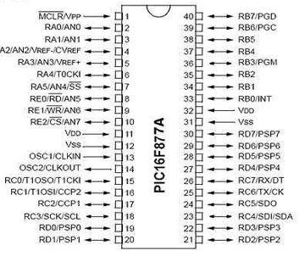

*Figure (1): pic microcontroller 16F877A*

* **The Step motor:**

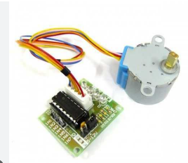

*Figure (2): stepper motor*

Is a DC electric motor that divides a full rotation into number of equal steps

There are three different phases of current waveforms:

1. Wave drive (one phase on)
2. Full-step drive (two phases on)
3. Half-stepping

We have designed our three motors to work on a full step drive to rotate in specific speed and specific number of rotations to push the item.

* **The IR sensor:**

An infrared sensor (IR sensor) is a radiation-sensitive optoelectronic component with a spectral sensitivity in the infrared wave.

In our design we have used two IR sensors, each is responsible for detecting and counting the coins that have been inserted.

The first IR sensor is used for the (5 qirsh).

The second IR sensor is used for (50 qirsh).

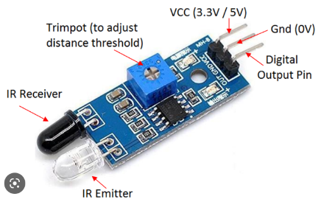

*Figure (3): IR sensor*

* **A liquid-crystal display (LCD):**

LCDs are available to display arbitrary images (as in a general-purpose computer display).

There are two modes in the LCD the 4-bit mode and the 8-bit mode, in our project we have used the 4-bit mode that takes 4 pins (data pins) only.

Also, we have used the LCD to display the inserted coins and then take instructions (using the keypad) to display the item's price.

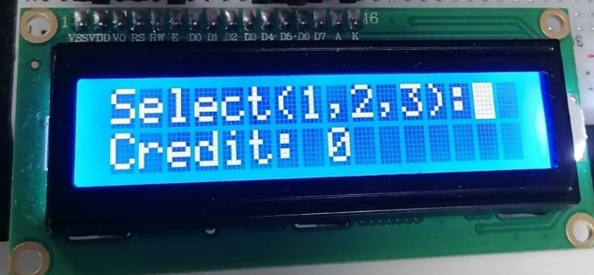

*Figure (4): LCD*

* **The keypad:**

A 4x3 keypad membrane matrix that is connected using 7 digital pins.

The one we used for our project needs a weak pull up resistor and we had to connect the keypad to PORT B specifically since it’s the only port that has a weak pull up resistor. (Output pins were set to high).

3 input pins(columns) and 4 output pins(rows).

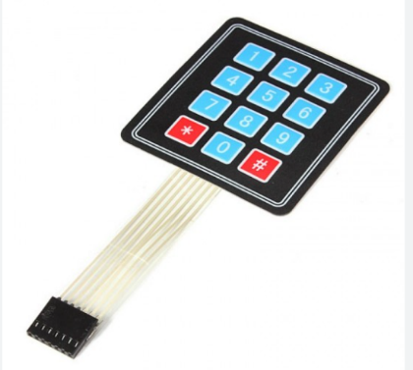

*Figure (5): Keypad*

* ***Design (Mechanical, Electrical, Software)***

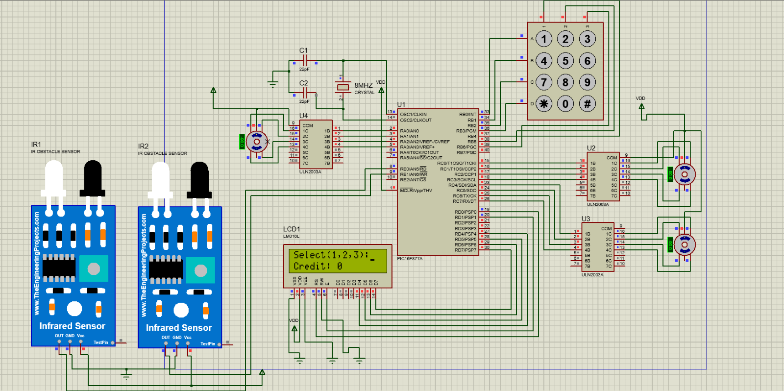

Figure (6): hardware design

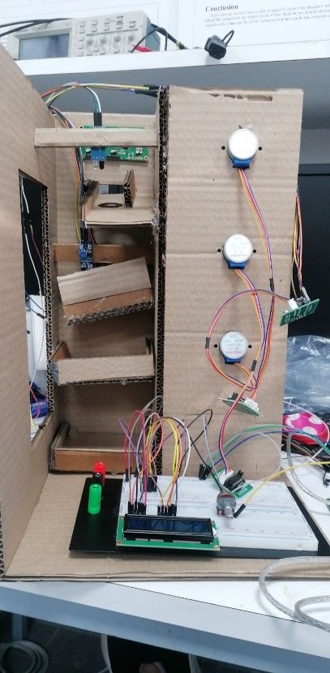

Figure (7): Physical design 1st Prototype

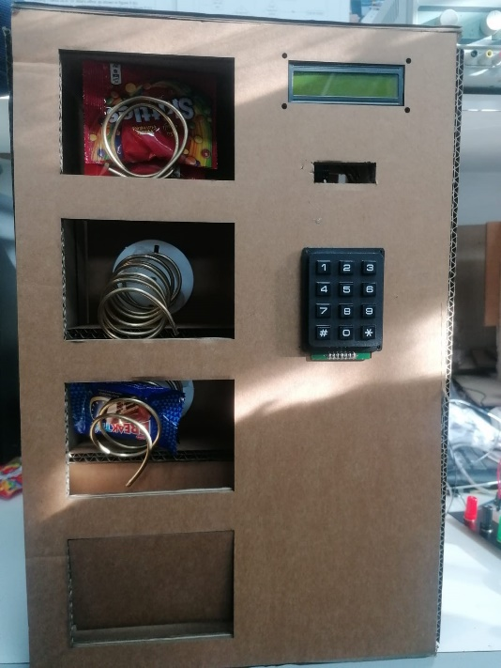

Figure (8): Physical design 2nd Prototype

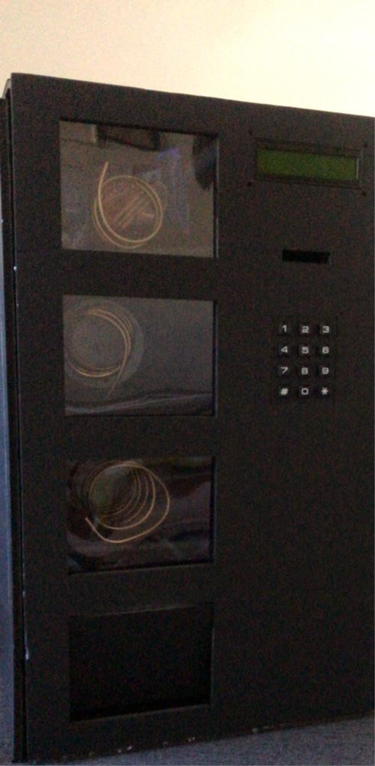

Figure (9): Physical design 3rd prototype

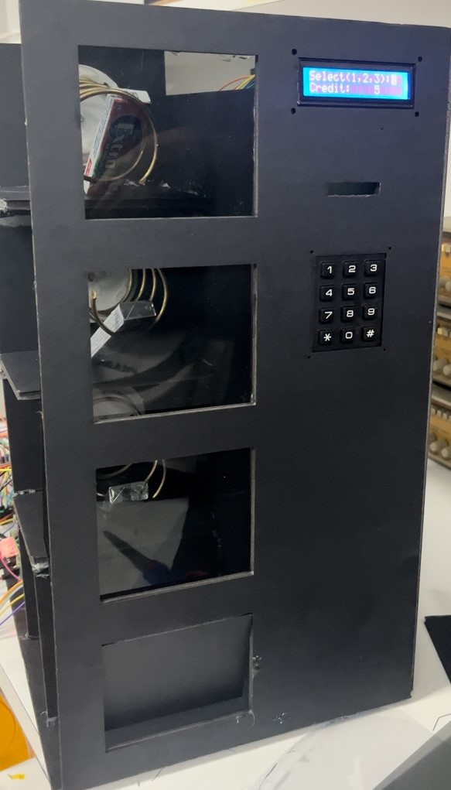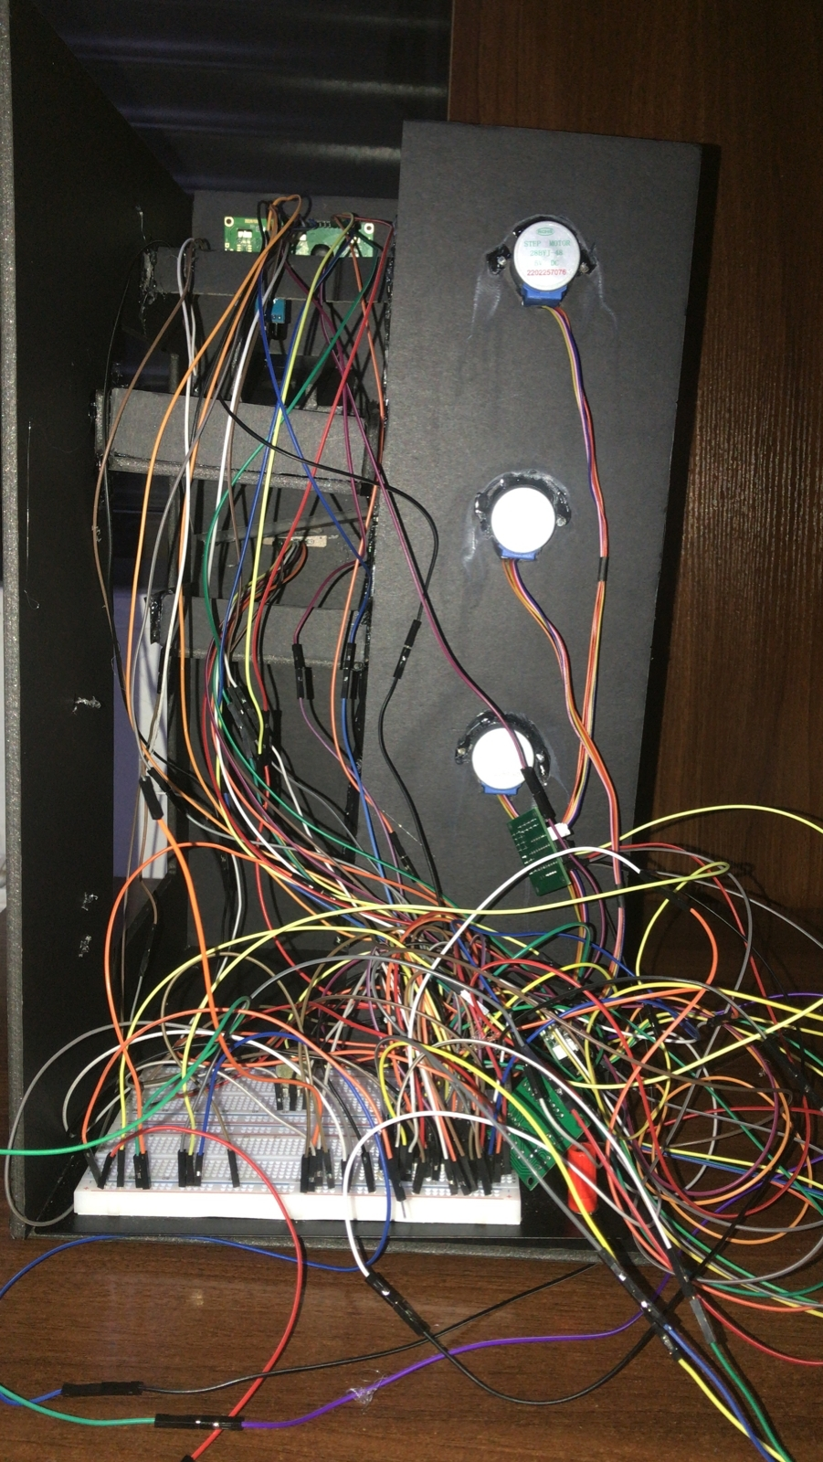

Figure (10): Physical design last prototype (current vending machine)

**Software:**

**Code :**

**The code is attached to the file**

**Flow chart :**

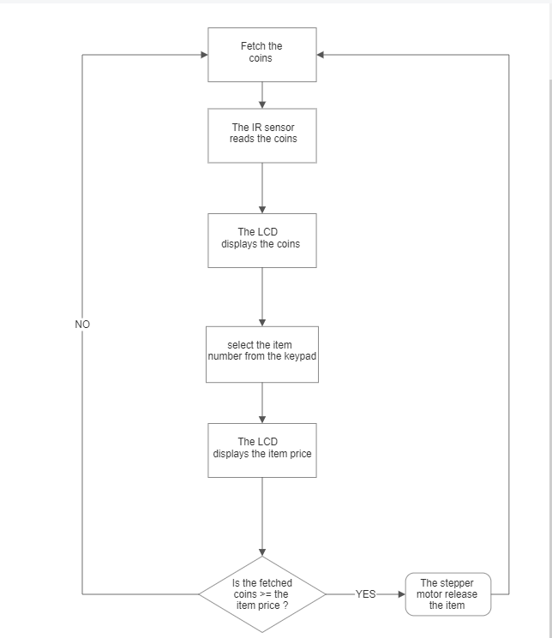

* ***Problems and recommendations***

**Software problems:**

Our code was written from scratch, since we found it better to write everything by ourselves rather than using libraries.

Problems we’ve faced during the project:

Problem 1:

At first, we thought that we couldn’t use any sort of libraries, so we started making libraries for the LCD from scratch, and it took so much time as the LCD functions are disclosed by MikroC Corp.

Problem 2:

The most challenging thing was implementing the code for the keypad, that we also had to write its code from scratch, since we’ve had it connected on PORTD and the LCD on PORTB which made the internal pull up resistors useless to deal with the keypad (Option_reg).

Problem 3:

We’ve faced Program memory issues due to the writing of the libraries from scratch, which we fixed by deleting unnecessary functions that doesn’t really affect implementation of the vending machine.

Problem 4:

The implementation of Timer 2 interrupt code was near impossible since we are dealing with 2k bytes as designated to be given by MikroC pro program (Free trial) as thought, as the 16f877a microcontroller works with 8k bytes it would’ve been possible to implement using the full version of MikroC pro program.

Problem 5:

We’ve also implemented the RB0 external interrupt push button to rule out the problem, as we did, the problem in fact wasn’t from the program memory, the LCD output had a problem with not showing the correct text output after many trials and error of using the interrupt function.

Problem 6:

The wiring of the project was also challenging since we have 3 stepper motors,LCD,2 IR sensors and a keypad, a total of (39) pins to be connected to the 16f877A MCU & Gnd/Vcc.

Problem 7:

We had to fix the incline of the sledge to work perfectly for the coins, as the tight space which it was in.

It needed an exact measurement to be done correctly.

**Hardware problems:**

* The thing we had the most trouble dealing with was that the code was working on the (ready for pic board) perfectly, but when moving it to the breadboard errors occurred. Many of these errors occurred due to infinite loops (that should’ve been broken after the execution of the required function) in the code that we missed, and they were later fixed. Other errors happened due to wiring problems or components pin connection mistakes.
* As we have mentioned before we have designed a slide for the coins, we faced such a problem with it (having to set it on the right angle) that we had to figure out on how to make it read each of the coins at such an angle it was in.

**Recommendations:**

* Make sure the code is carefully done without any infinite loops that doesn’t move you back to the main program.
* Check each component code and hardware implementation alone before testing the whole code of the project.
* Test each component on both -the ready for the pic board- and the -breadboard- to make sure nothing is wrong.
* Make sure the power is suitable for each component and current sink and current source is considered.
* ***Conclusion***

Working with 16F877A pic is not easy as dealing with the Arduino, however dealing with the pic microcontroller is used for many applications and we needed to learn how to use it and how to deal with it in this embedded systems course.

By applying embedded system course principles, we used pic16F778A to Build a vending machine from scratch also we’ve used different types of motors and sensors and how to implement the code and the hardware design for each of them.

Using the LCD and the Keypad is very important since they are used frequently in almost every Embedded system, we have used or going to use in the future.

**Our video:**

[**A Vending Machine Project using a 16f877A Microcontroller -Group 6- (2022-2023)**](https://www.youtube.com/watch?v=FM8aZPlFrs8)

[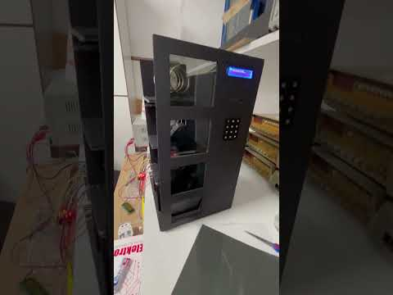](https://www.youtube.com/watch?v=FM8aZPlFrs8)